Circle Language Spec: Black Boxes

Public & Private

Public Set / Access Connectors
The general notation of an access connector is as follows:

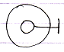

The sub-object is access controlled by the parent object. The line with the stick at the end is the access connector.

It is also the general notation of a Public access connector.
More specifically: it is a Public Set access connector, because it denotes, that you can make it point to something.

Public Get
The notation of the Public Get access connector is:

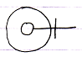

Because this denotes, that you can point to it.

Private Set
The general notation of Private is:

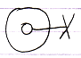

The cross expresses ‘inaccessible’ or better said ‘restricted’. Access is restricted to only a limited group of objects: the friends.

More specifically: it is a Private Set connector, because it denotes that making it point to something else is restricted.

Private Get
The notation of the Private Get access connector is:

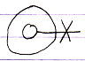

Because this denotes, that pointing to it is restricted.

Author & Copyright: Jan-Joost van Zon Date: June 26, 2009 – July 18, 2009 Location: Oosterhout, The Netherlands Status: Finished

